Anime Recommendation

Name: Mokshita varma Varada raju Montgomery,Alabama, USA

Abstract— Anime over following years gained popularity, with many names and genres available to entertain the audience. However, due to various anime audiences are facing challenges on what might suit their interests. The project with the of My SQL database to store anime related details like title, genre, and ratings.

Introduction

Anime is known by many people around the world and enjoy watching a wide range of various genres, making it difficult for the viewers to recognize shows that interest them. This database project intends to improve anime seeking process by setting a database that gives suggestions which helps the viewer to pick a choice according to their interests. This database will hold the knowledge about each anime which includes its title, genre, episodes, etc. This project will be designed for accuracy and ease to use, to help anime fans to easily find new shows that might match their options and enhance of watching anime.

LITERATURE REVIEW
The database is for helping in providing audience with anime details based on “content-based filtering”. This database uses “content-based filtering techniques” to help find an anime that suits their preferences by concentrating on factors like genres. where audience can find or filter related preferences in genres like action, slice of life, comedy, drama, etc. By using these elements, the database suggests or shows related anime that matches the audience’s preferences, offering a particular searching experience that allows viewers to find new anime based on their favorite genres. This ensures that anime watchers can easily search anime filtered to their tastes, making it easier to discover titles they will enjoy.
The data set taken from “Kaggle website” has around 2000 unique values. This dataset contains around eleven sections related to anime that are name, ranking, genre, rating, etc. This dataset was taken from “myanimelist.com”.

METHODOLOGY
This initiated anime recommendation project is an SQL database project created to store, take or manage information about anime like name, episodes, type, ratings, etc. This project is a combination of data collection and filtering of data to ensure accurate suggestions or results.

The dataset used for this project was collected from “Kaggle” website which is considered a platform for datasets for project related. The dataset utilized for the project has around “2000 unique values” with a data including details of anime like name, genre, followers, rating, etc. The data collected was in “CSV file”.

Before stating to analyze or store data, filtering of data was done to ensure reliability and excellence. The missing or empty values were replaced with word “NULL” indicating that there were no values in that for example in genre column. The data implemented in the project were 1115 unique values (that is 1115 rows).

For this project, a “relational database” was created using “MYSQL WORKBENCH” to store and manage the filtered data. The essential framework (schema) includes four tables which are as follows:

- Anime: Contains information about name, type, episodes, and primary key ranking.
- Genre anime: Contains information about ranking, genre, demographics, age.
- Anime ratings: Contains ranking, rating, and followers (followers in this case means how many people watched it or followed it in the “myanimelist.com” website).
- Anime licenses: Contains ranking, license, study.

The table anime acts as a “Parent table” with ranking column as the primary key. This primary key is referred to as foreign key in other three table highlighting a “one-to-many relationship” and “foreign key constraints” in the database. This helps in data joins and supports analytical search about all the information about anime.

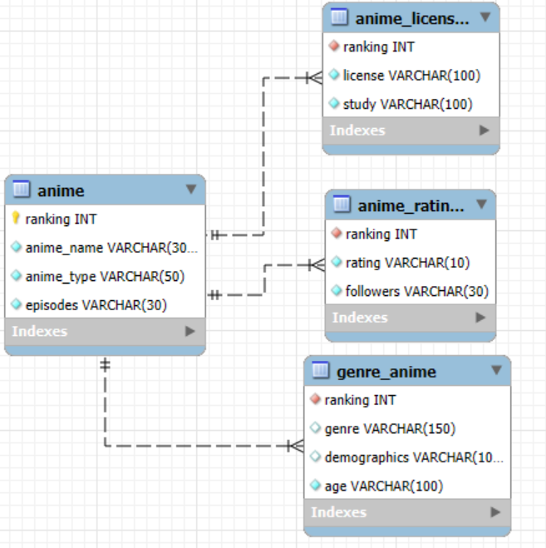

For this project we can use analytical operations to implement recommendations with the help of “Content-Based Filtering” which helps in finding similar genre anime, etc. We can also use “Popularity-Based Filtering” As we can filter top rated anime in it or most followed anime, stored in database.

To check how the recommendation system works, this database is tested using queries (sample inputs) and imitated user choices. Since the system does not have a user interface (human to computer interaction). So, we have manually checked or looked at the recommendations to see if they worked based on the information.

There are few limitations in this project, firstly this project does not collect real user feedback or response, so we cannot be sure on how useful the recommendations made will be useful/helpful in real world. Secondly, the data used for the project is limited. The dataset taken from “Kaggle” website has around 2000 entries but only 1115 entries were taken due to problem can be file error while downloading during collecting data. This might affect the coverage of recommendations for anime. Finally, the project evaluated was with a small amount of data, so we cannot be sure how it works with large amount of data.

CONCLUSION
Overall, this project created a basic anime recommendation system using an organized data and “content-based filtering”. By collecting data from public sources, like “Kaggle” and the system can suggest anime with genre similarities, top anime rating filtering.
While the system works well with simple recommendations there are few limitations to it, including the using only “content-based filtering”, lack of real user suggestions/feedback. In future work, the recommendation quality can be improved by adding “collaborative filtering” and adding many features such as user feedback and expanding the dataset.
To conclude, this project shows how even a small and well-structured dataset can be used to build a recommendation system for anime fans/followers.

References

  - [1]
“Anime dataset,” Kaggle, Anime dataset (accessed Apr. 20 2025).

  - [2]
Sajid030, “GitHub - Sajid030/anime-recommendation-system: Personalized anime recommendations based on collaborative filtering. Discover your next favorite anime!” GitHub, 2023. Sajid030/anime-recommendation-system: Personalized anime recommendations based on collaborative filtering. Discover your next favorite anime! (accessed Mar. 26, 2025).
  - Marawanattya, “GitHub - marawanattya/Anime-Recommendation-System,”GitHub.Available: https://github.com/marawanattya/Anime-Recommendation-System?tab=readme-ov-file

